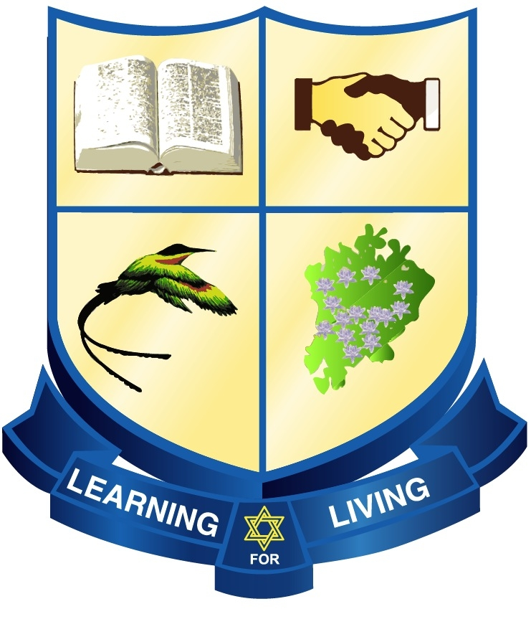

HILLEL ACADEMY

2025- 2026 SCHOOL CALENDAR

TERM 1

MONDAY, SEPTEMBER 8, 2025 –FRIDAY, DECEMBER 12, 2025
AUGUST WEDNESDAY 27
THURSDAY 28
FRIDAY 29 STAFF PROFESSIONAL DEVELOPMENT WEEK
MONDAY 01 IB ORIENTATION AND BOOT CAMP
SEPTEMBER TUESDAY 02

SEPTEMBER WEDNESDAY 03 STUDENT AND PARENT ORIENTATION
THURSDAY 04
FRIDAY 05
MONDAY 08 ALL CLASSES RESUME
TUESDAY 23 ROSH HASHANNA (Jewish Holy Day) ~ School Closed

OCTOBER THURSDAY 02 YOM KIPPUR (Jewish Holy Day) ~ School Closed
OCTOBER FRIDAY 17 MID-TERM BREAK
MONDAY 20 NATIONAL HEROES’ DAY School Closed

NOVEMBER SATURDAY 22 HS PRIZEGIVING

DECEMBER THURSDAY 11 CAROL AND HANNUKAH HOUR
FRIDAY 12 SCHOOL CLOSES FOR CHRISTMAS HOLIDAYS (12 Noon)

TERM 2

MONDAY JANUARY 5, 2026 – WEDNESDAY APRIL 1, 2026

JANUARY MONDAY 05 ALL CLASSES RESUME

FRIDAY 09 FOUNDERS DAY ASSEMBLY

FEBRUARY WEDNESDAY 18 ASH WEDNESDAY

THURSDAY 19 & School Closed

FRIDAY 20 MID-TERM BREAK
FRIDAY 27 PANTHER PAWS – EARLY RELEASE DAY (HIGH SCHOOL ONLY)

MARCH FRIDAY 20 PS and HS ROAD RACE
FRIDAY 27 PS SPORTS DAY
TUESDAY 31 HS SPORTS DAY
APRIL WEDNESDAY 01 SCHOOL CLOSES FOR EASTER HOLIDAYS

TERM 3

MONDAY APRIL 13, 2026 – FRIDAY JUNE 26, 2026

APRIL MONDAY 13 ALL CLASSES RESUME

MAY WEDNESDAY 06 TEACHERS DAY
THURSDAY 07 BOOK FAIR
FRIDAY 08 BOOK FAIR
WEDNESDAY 20 PANTHER PAWS – EARLY RELEASE DAY
THURSDAY 21 MID-TERM BREAK
FRIDAY 22 & School Closed (Except For External Exams)
MONDAY 25 LABOUR DAY

JUNE TUESDAY 16 GRADE 13 GRADUATION
WEDNESDAY 17 GRADE 6 GRADUATION
THURSDAY 18 GRADE 11 GRADUATION
THURSDAY 25 PS PRIZEGIVING
FRIDAY 26 SCHOOL CLOSES FOR SUMMER HOLIDAYS (12 Noon)

- Every effort Is made to adhere to the calendar; However, circumstances could make some dates subject to change.

